Chapter 1
Introduction
1.1 Introduction of the System
In VEHICLE ASSISTANCE NETWORK application, giving your vehicles for service is much easier and reliable when compared to the existing methods. In the proposed system every customer of a showroom will be allocated with the job card where job card contains all the important information related to the service of the vehicle. Here after running the vehicle for certain kilometres as per suggested by the company if the vehicle is in need to service then the customer can use this application to do so. Using this application customer can notify the service centre about the damage occurred to the vehicle, following which the service centre will go through it and can allocate the date and time for the customer for their vehicle to get serviced also they will reveal the date of delivery of the vehicle after service. In some situations, it’s possible that vehicles are more damaged than the service limit and need to be repaired in such situations service centre can reject the service requested by the customer through this application itself, hence service approval or rejection is also included here. This application is a great tool for today’s busy life as it saves lot of time, energy and also is much reliable and efficient.
    - Project Title
VEHICLE ASSISTANCE NETWORK
    - Category
Web application and RDBMS
    - Overview
Automated Systems improve efficiency for everyone involved. The Employee Spends less time on paper work and more time monitoring the happening progresses. Record keeping is easier and more accurate.

1.2.2 Brief note on Existing System
Existing System is paper based recording. It is difficult since if we need particular information we have to move on the pages. Vehicle Assistance Network overcomes the limitation of paper-based recording.
  - Objectives of the System
- To help customers in getting timely service to the vehicles.
- To help customers in notifying the service centre about the damage occurred to the vehicle.
- To Reduce the manual work.
- To save time.

  - Scope of The Project
- The purpose of this project is to overcome the drawbacks of traditional method where customer must wait to get the vehicle serviced.
- Here the customer will be notified once the service is due which helps the customer to get timely service.
- This application is a great tool for today’s busy life as it saves lot of time,

  - Structure of the System
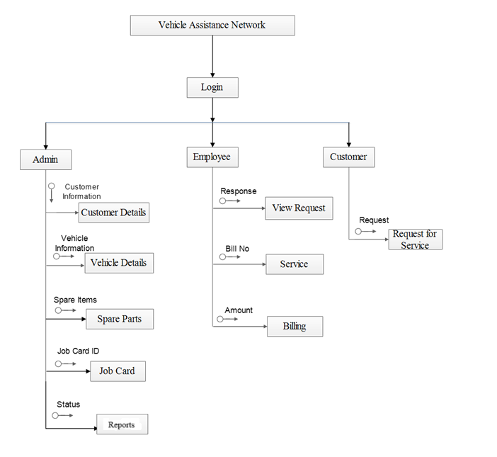
Fig 1.1: System Structure

1.6 System Architecture
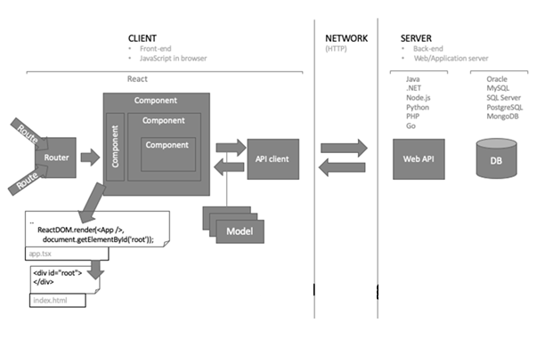
Fig 1.2: Architecture of the system
  - End Users
The System is designed with the intension to provide easy to use simple system so that no cumbersome and elaborate training for operation is needed. Admin can add details about customer and employee. The Admin is the main user of the system.
Admin: Admin has all the control over monitoring the vehicle services. He is responsible to allot the appointment to the customers for the service. The admin views various users of the application. He is responsible to do the service due notification. He adds all the customer details and job card details.

  - Software/Hardware used for the development
1.8.1 Hardware Requirements:
- RAM: 1GB or above
- Hard disk: 10 GB or above
- Processor: 2.4 GHZ or above
1.8.2 Software Requirements:
- Back end: My SQL 5.0
- Languages: Asp.Net
- Frame work: .Net Frame work 4.0
- Operating system: Windows 7 or above
- Server: IIS 7.0
  - Software/Hardware required for the implementation
- Operating System: Windows 7/Windows 8
- Hard disk: minimum 4 GB,512 MB or above RAM
- Visual Studio 2010-version 10.0.30319.1 RTMRel
- Version: MySQL 1.2.12.

Chapter 2
SOFTWARE REQUIREMENT SPECIFICATIONS

2.1 Introduction
A software requirements specification (SRS) is a description of a software system to be developed, laying out functional and non-functional requirements, and may include a set of use cases that describes the interactions between the users and the software.
Software requirements specification establishes the basis for agreement between customers and contractors or suppliers on what the software product has to do as well as what it is not expected to do. Software requirements specification permits a rigorous assessment of requirements before design can begin and reduces later redesign. It should also provide a realistic basis for estimating product costs, risks, and schedules.
The software requirements specification document enlists enough and necessary requirements that are required for the project development. To derive the requirements, we need to have clear and thorough understanding of the products to be developed or being developed. This is achieved and refined with detailed and continuous communications with the project team and customer till the completion of the software.
2.2 Overall Description
Using this application customer can notify the service centre about the damage occurred to the vehicle, following which the service centre will go through it and can allocate the date and time for the customer for their vehicle to get serviced also they will reveal the date of delivery of the vehicle after service. In some situations, it’s possible that vehicles are more damaged than the service limit and need to be repaired in such situations service centre can reject the service requested by the customer through this application itself, hence service approval or rejection is also included here.
This application is a great tool for today’s busy life as it saves lot of time, energy and also is much reliable and efficient.

2.2.1 Product Perspective
Product perspective is essentially the relationship of the product to other products, defining if the product is independent or is part of a larger product.
This is a new, self-contained online evaluation of the project in which the system every customer of a showroom will be allocated with the job card where job card contains all the important information related to the service of the vehicle. Using this application customer can notify the service centre about vehicle to be repaired in such situations service centre can accept or reject the service requested by the customer through application itself, hence service approval or rejection is also included here.

2.2.2 Product Functions
- User creation.
- Login.
- Add employee.
- Job card.
- Service.
- Spare parts.
- Service update.
- Request Service.
- View approval.
- Payment.

2.2.3 User Classes and Characteristics
The system is designed with the intension to provide easy to use simple system so that no cumbersome and elaborate training for operation is needed.
Project evaluation has 3 levels:
Admin:
Admin has all the control over monitoring the vehicle services. He is responsible to allot the appointment to the customers for the service. The admin views various users of the application. He is responsible to do the service due notification. He adds all the customer details and job card details.
Client:
The client adds all the details of the services and also the details of the payment and the information is loaded to the client. They create their accounts with their username and password to access the application.
Employee:
The employee checks all the service problem and the service will be approved or disapproved. Each of them will have their own id and password and they can access the service details.

2.2.4 General constraints
- All the fields or required information has to be provided while registering.
- The application should have a relational database.
- The application shall display error messages to the user when an error is detected.
- It can be reusable and verifiable.
- It supports appropriate changes.

2.2.5 Assumptions
- The system is completely dependent on internet connection.
- The Information provided by the user is assumed to be genuine.
- The activity should be authorized by the admin.
- Every vehicle owner should be registered to use the system.
- The mobile network should be available to receive notifications through SMS.
- The information is maintained safe and secure.

2.3 Special Requirements
Not applicable

2.4 Functional Requirements
Functional Requirement specifies which output should be produced for the given inputs. All inputs are entered according to the data type and no blanks are allowed for mandatory fields. Invalid inputs are not allowed in the system. It prompts to re-enter the data. Appropriate error messages are displayed.
- User Creation: In this module Admin gives the username and password to the particular users.
Input : User ID, User Name, Password, User Type.
Output : Authorized page will be displayed.
Processing : If the username and password is incorrect then the error message is displayed.

- Customer Details: This module is used to view the customer details.
Input : Customer ID, Customer Name, Address, Contact Number, E-Mail ID.
Output : Customer details has been entered.
Processing : If the Customer details is invalid then the error message is displayed.

- Job Card: This module contains information about vehicles.
Input : Vehicle Number, Customer ID, Employee name.
Output : Information about vehicles will be displayed.
Processing : If the vehicle is number is invalid then the error message is displayed.
- Vehicle Details: This module is used to store the vehicle details.
Input : Customer id, Vehicle number, Model number, Chassis number, Insurance Number.
Output : Authorized page will be displayed.
Processing: If the details about the vehicle is incorrect the error message is displayed.
- Service: In this module the service information is being displayed.
Input : Service ID, Vehicle Number, Description.
Output : Authorized page will be displayed.
Processing : Service Id must be same.
- Billing: In this module bill is been done.
Input : Bill Number, Service ID, Amount.
Output : Billing is done.
Processing : Service ID must be same.
- Spare Parts: This module is used to enter the name of the spare parts.
Input : Spare ID, Spare Name.
Output : Checks whether the project exists or not.
Processing : If the spare id is incorrect then the error message is displayed.
- Login: In this module, user has to enter the username and password in order to login to the system.
Inputs : Current password, new password, Confirm password.
Output : Authorized page will be display.

2.5 Design Constraints:
- Email field to be entered with text in email format itself.
- Requires to specify the information for all the mandatory fields.
- The application shall have a relational database.
- The application shall be implemented using asp.net MYSQL 5.0, and Microsoft Visual studio 2010.
- The application shall display error messages to the user when an error is detected.

2.6 System attributes
This section of the vehicle assistance network SRS describes the applications attributes and properties.
- Availability : vehicle assistance network shall be available in internet 24x7 and capable of supporting a multiple login.
- Security : vehicle assistance network shall be managed by the administrator via predetermined roles.
- Maintainability: During maintenance stage, the SRS can be referred for the validation
- Portability : Since it is a system, it is portable.
- Timeliness : The system carries out all the operations with consumptions of very less time

Chapter 3
SYSTEM DESIGN

3.1 INTRODUCTION
System design is essentially a bridge between requirement specification and final solution for the requirements. This focuses on deciding which components needed for the system, the specification of those components and how components should be interconnected.
The most challenging and creative system development cycle is system design. The term describes the final system and process by which it is developed. It also includes the construction of the program and program testing the question here is know should be the problem solved? The design is about how to approach compare to analysis. What is orientation? It translates the system requirements in to detailed implementation, the system recommended in the feasibility study.

3.2 ASSUMPTIONS AND CONSTRAINTS
- User must be knowing initial computer operating techniques.
- System is depending on the connection of the internet.
- The required data provided by the operator is assumed to be genuine.

3.3 FUNCTIONAL DECOMPOSITION

3.3.1 System software architecture
The term Software Architecture intuitively denotes the high-level structure of a software system. It can be defined as the set of structures need to understand the software system, defined the software elements, the relations between them, and the properties of both elements and relations.

3.3.2 System technical architecture:
The Web server (IIS 7.0) used to execute SQL query and MYSQL server used to store database records. The project “Lawyers dairy” works under following technical architecture:

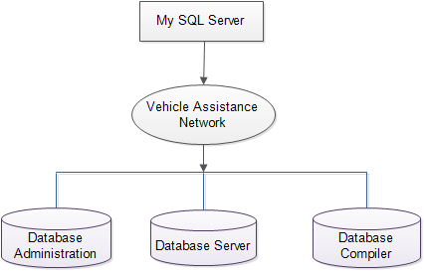
Fig 3.1 System technical architecture

    - System Hardware Architecture
Hardware architecture refers to the identification of a system’s physical components and their interrelationships. this description, often called a hardware model, allows hardware designers to understand how their components fit into system architecture and provides software components designers important information need for software development and integration.

  - DESCRIPTION OF PROGRAMS

3.4.1 Context Flow Diagram (CFD)

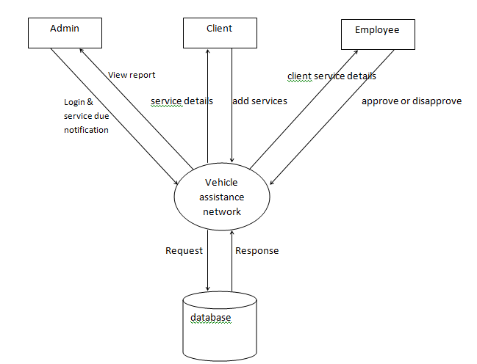
Fig 3.2 Context Flow Diagram

3.4.2 Data Flow Diagram (DFD)
3.4.2.1 DFD FOR ADMIN
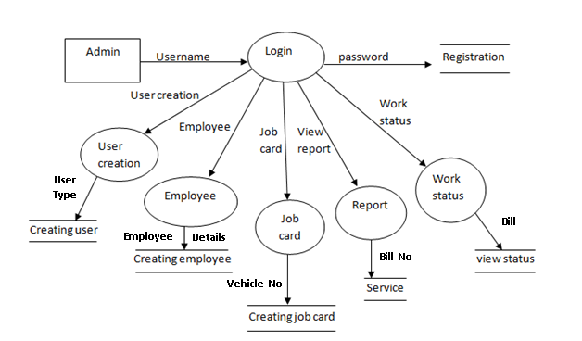
Fig 3.3 DFD FOR ADMIN
3.4.2.2 DFD FOR EMPLOYEE
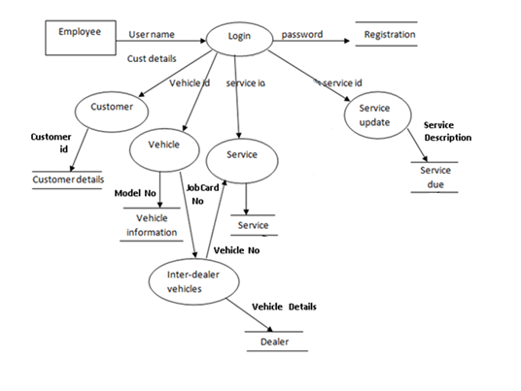
Fig 3.4 DFD FOR EMPLOYEE
3.4.2.3 DFD FOR CLIENT:
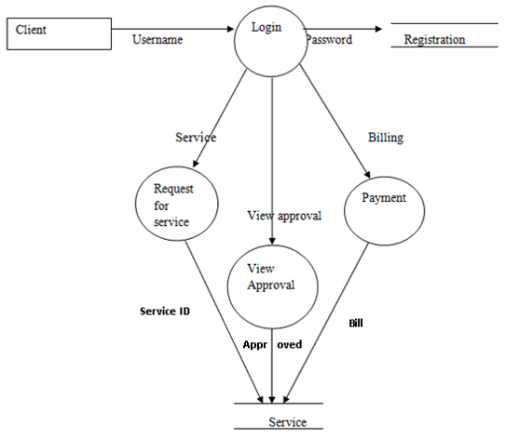
Fig 3.5 DFD FOR CLIENT
  - Description of Components
3.5.1 User Creation: In this module Admin gives the username and password to the users.
Input : User ID, User Name, Password, User Type.
Output : Authorized page will be displayed.
Processing : If the username and password is incorrect then the error message is displayed.
3.5.2 Customer Details: This module is used to view the customer details.
Input : Customer ID, Customer Name, Address, Contact Number, E-Mail ID.
Output : Customer details has been entered.
Processing : If the Customer details is invalid then the error message is displayed.
3.5.3 Job Card: This module contains information about vehicles.
Input : Vehicle Number, Customer ID, Employee name.
Output : Information about vehicles will be displayed.
Processing : If the vehicle is number is invalid then the error message is displayed.
3.5.4 Vehicle Details: This module is used to store the vehicle details.
Input : Customer id, Vehicle number, Model number, Chassis number, Insurance Number.
Output : Authorized page will be displayed.
Processing : If the details about the vehicle is incorrect the error message is displayed.
3.5.5 Service: In this module the service information is being displayed.
Input : Service ID, Vehicle Number, Description.
Output : Authorized page will be displayed.
Processing : Service Id must be same.
3.5.6 Billing: In this module bill is been done.
Input : Bill Number, Service ID, Amount.
Output : Billing is done.
Processing : Service ID must be same.
3.5.7 Spare Parts: This module is used to enter the name of the spare parts.
Input : Spare ID, Spare Name.
Output : Checks whether the project exists or not.
Processing : If the spare id is incorrect then the error message is displayed.
3.5.8 Login: In this module, user has to enter the username and password in order to login to the system.
Inputs : Current password, new password, Confirm password.
Output : Authorized page will be display.
CHAPTER 4
DATABASE DESIGN
4.1 INTRODUCTION
Database Design is a collection of processes that facilitate the designing, development, implementation and maintenance of enterprise data management systems. The main objectives of database designing are to produce logical and physical designs models of the proposed database system. The logical model concentrates on the data requirements and the data to be stored independent of physical considerations. It does not concern itself with how the data will be stored or where it will be stored physically.
4.2 PURPOSE AND SCOPE
Organizations use large amounts of data. A database management system (DBMS) is a software tool that makes it possible to organize data in a database. The database in turn is further described in detail giving all the fields used with their data type, constraints available to them and description. Constraints include primary key, foreign key, etc., which allow the entities to be uniquely identified.

4.3 DATABASE IDENTIFICATION
- Database table name and column names are defined without leaving space.
- Lower case is used to create table and column names.
- Primary key and foreign key are define using the same name.
4.4 SCHEMA INFORMATION
4.4.1 Description
The description of the database is called database schema. A database schema is specified during database creation and is not accepted to change frequently. Most data model has certain conversation for diagrammatically displaying schema. The schema diagram displays only some aspects of schema, such accepts are not specified in the diagram that is neither the data type of each data item that changed frequently. The data in the database moment in timer is called a database state.
4.5 TABLE DEFINITION

CUSTOMER_DETAILS
Customer_ID | Customer_Name | Address | Contact_No | Email_id

JobCardID | Vehicle_No | Customer  _Name | Employee  _Name | Problem | JobCardNo | Date | Deliivery_date | subdate
JOBCARD

REGISTRATION
reg_id | Username | Password | usertype | phone | Email | Salary

REQUEST_FOR_SERVICE
Service_Approval_ID | Vehicle_No | Registered_Date | Problem | Submission_Date | JobCardNO

SERVICE
Service_ID | Bill_No | JobCard_No |  | vehicle_no |  | customer_name |  | Adderss | phone | sub_date | Problem | delv_date
service_amt | spare_part |  | Price |  | Qty |  | total |  | Net

VEHICLE_DETAILS
Vehicle_ID | Customer_name |  | Vehicle_Number | Model_Number | Insurance_Number | vehicle_type
variant | fuel_type

4.6 Physical Design
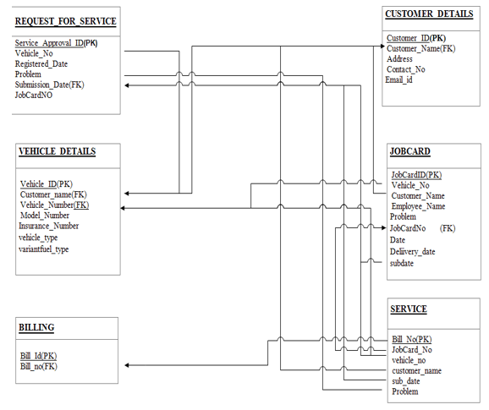
Fig 4.1 Physical Design
4.7 Data Dictionary
Registration:
Vehicle-Details
Attribute | Datatype | Constraints
Vehicle_ID | INTEGER | Primary key
Customer_ID | VARCHAR(10) | Not Null
Vehicle_Number | VARCHAR(10) | Not Null
Model_Number | VARCHAR(20) | Not Null
Insurance_Number | VARCHAR(20) | Not Null
Table:4.1 Vehicle-Details
Job Card
Attribute | Datatype | Constraints
JobCardID | INTEGER | Primary key
VehicleNo | VARCHAR(10) | Not Null
CustomerName | VARCHAR(25) | Not Null
EmployeeName | VARCHAR(25) | Not Null
Problem | VARCHAR(45) | Not Null
Table:4.2 Job Card
Service
Attribute | Datatype | Constraints
Service_ID | INTEGER | Primary key
Bill_No | VARCHAR(10) | Not Null
Vehicle_No | VARCHAR(10) | Not Null
Customer_Name | VARCHAR(25) | Not Null
Employee_Name | VARCHAR(25) | Not Null
Jobcard_No | VARCHAR(10) | Not Null
Amount | VARCHAR(10) | Not Null
Description | VARCHAR(25) | Not Null
Problem | VARCHAR(45) | Not Null
No of Days | VARCHAR(10) | Not Null
Approval | VARCHAR(25) | Not Null
Table:4.3 Service

Request for service
Attribute | Datatype | Constraints
Service_approvalID | INTEGER | Primary key
Jobcard_No | VARCHAR(10) | Not Null
Vehicle_No | VARCHAR(10) | Not Null
Customer_Name | VARCHAR(25) | Not Null
Date | VARCHAR(10) | Not Null
Approved | VARCHAR(25) | Not Null

Table:4.4 Request for service
Spare parts
Attribute | Datatype | Constraints
Spare_ID | INTEGER | Primary key
Spare_Name | VARCHAR(25) | Not Null
Table:4.5 Spare parts
Billing
Attribute | Datatype | Constraints
Bill_No | INTEGER | Primary key
Service_id | VARCHAR(10) | Not Null
Date | VARCHAR(10) | Not Null
Amount | VARCHAR(10) | Not Null
Description | VARCHAR(35) | Not Null
Table:4.6 Billing

4.8 ER DIAGRAM
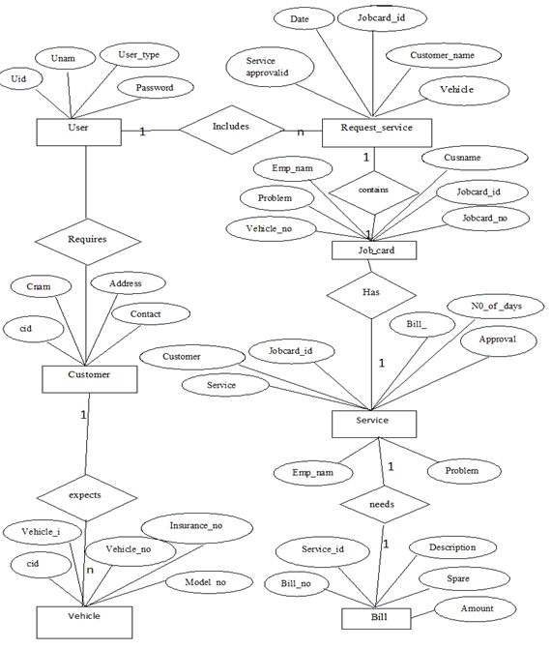
Fig 4.2 ER DIAGRAM
4.9 DATABASE ADMINISTRATION
4.9.1 SYSTEM INFORMATION
- Frontend: visual studio 2010
- Backend: Mysql 5.0
- Language: C#.net,asp.net,html
- Framework: .net framework 4.0
- Server: IIS 7.0
- Operating system: windows 7 or above
4.9.2 DBMS CONFIGURTAION
The Ingres client-server architecture allows multiple users access to databases through connections to one or more DBMS Server processes. The DBMS Server is a multi-threaded daemon process that performs asynchronous disk input and output. The number of users connected to a server is limited by hardware or the operating system. A DBA must be able to think logically to solve all the problems and easily work in a team.
    - SUPPORT SOFTWARE REQUIRED:
The system installs MYSQL while installing visual studio 2010.All the backup contents are stored in MYSQL database.
    - Storage Requirements
- The Storage engine represent the heart of a MySQL Server
- Recovering the database from system failure
- Management of files and database pages used to store data
- Manage data buffers and system IO to the physical data pages
- Manage locking and concurrency issues

    - Backup and Recovery
Backup and recovery refers to the process of backing up data in case of loss and setting up system that allows the data recovery due to data loss Backing up data requires copying and achieving computer data, so that accessible in case of data deletion or corruption. The trade-off is that, at recovery time you cannot restore your data just by reloading the full backup. You must also process the incremental backups to recovery the incremental changes. Each time it restarts, the MYSQL server create a new binary log file using the next number in the sequence.

Chapter 5
DETAILED DESIGN
5.1 Introduction
Detailed design starts after the system design phase and system has been certified through the review. The goal of this phase is to develop the internal logic of each of the modules identified during system design.
In the system design, the focus is on identifying the modules, whereas during detailed design the focus is on designing the logic for the modules. In other words, in system design attention is on what components are needed, while in the detailed design how the components can be implemented in the software is the issue.
The design process for software system has two eves. At the first level focus is on deciding which modules are needed for the system, the specification of these modules and how the modules should be interconnected. This is called system design or top-level design. In the specification of the module can be satisfied is decided. This design level is often called detailed design or logic design.
Because the detailed design is extension of system design, system design controls the major structural characteristics of the system. The system design has a major impact testability and modifiability of a system and impacts its efficiency much of the design efforts for the designing software are spent creating the system design.

5.2 Structure of Software Package
The functional components identified during the system design are listed here:
Functional Component 1: Employee
Functional Component 2: Job Card
Functional Component 3: Customer Details
Functional Component 4: Service
Functional Component 5: Vehicle Details
Functional Component 6: Request for Service
Functional Component 7: Spare Parts
Functional Component 8: Billing

5.2.1 Structure chart of the system
5.2.1.1 Admin module
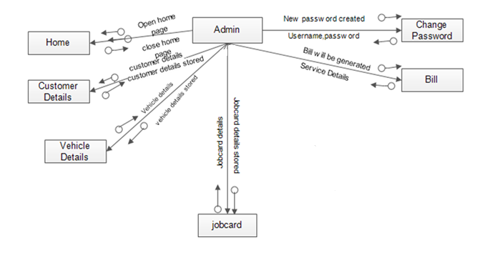
Fig 5.1 Admin module
5.2.1.2 Employee module
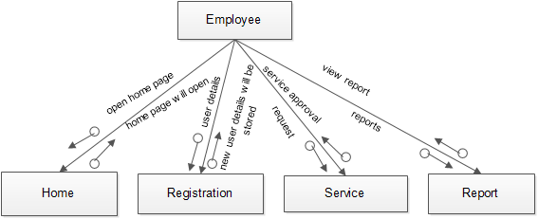
Fig 5.2 Employee module

5.3 Modular decomposition of the System
5.3.1 Module 1: Employee
Input: User ID, User Name, Password, User Type

Procedural Details (Flow Chart)
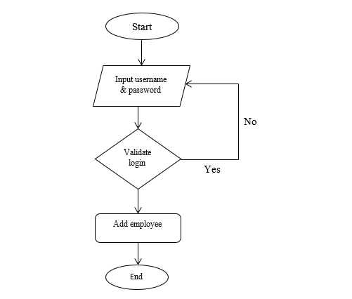

Fig 5.3 Structure Chart for Employee

File I/O: Employee
Output: Authorized page will be displayed.

5.3.2 Module 2: Job Card
Input: Vehicle Number, Customer ID, Employee name

Procedural Details (Flow Chart)
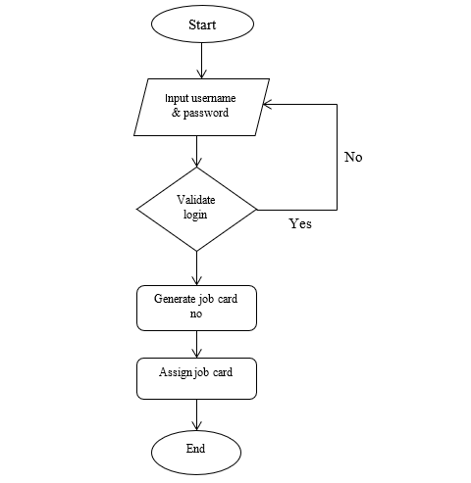

Fig 5.4 Structure Chart for Job Card

File I/O: Job Card, Vehicle Details, Customer Details
Output: Information about vehicles will be displayed.

5.3.3 Module 3: customer Details
Input: Customer ID, Customer Name, Address, Contact Number, E-Mail ID

Procedural Details (Flow Chart)
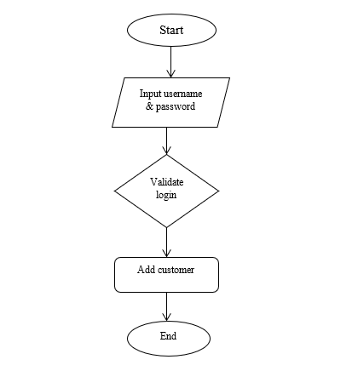

Fig 5.5 Structure Chart for customer Details

File I/O: customer Details
Output: Customer details is been entered.

5.3.4 Module 4: Service
Input: Service ID, Vehicle Number, Description
Procedural Details (Flow Chart)
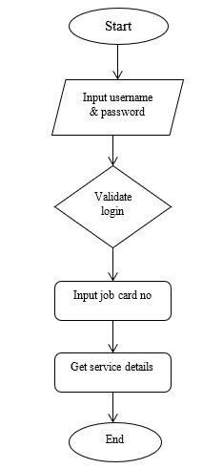

Fig 5.6 Structure Chart for Service

File I/O: Service, Vehicle Details, Customer Details, Job Card
Output: Authorized page will be displayed.

5.3.5 Module 5: Vehicle Details
Input: Customer id, Vehicle number, Model number, Chassis number, Insurance Number

Procedural Details (Flow Chart)
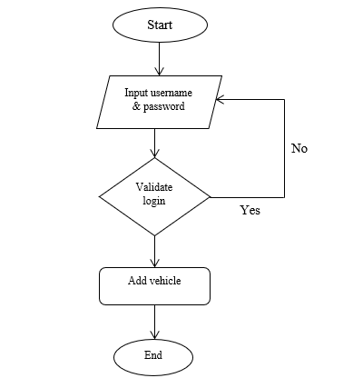

Fig 5.7 Structure Chart for vehicle Details

File I/O: Vehicle Details
Output: Authorized page will be displayed.

5.3.6 Module 6: Request for Service
Input: Service_Approval_ID, JobCard_No, Vehicle_No, Customer_Name, Date, Approved
Procedural Details (Flow Chart)

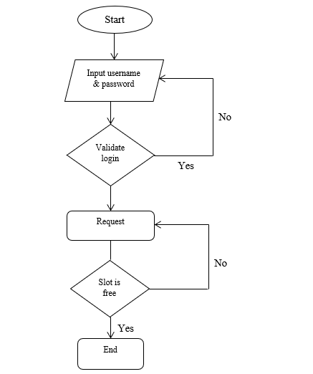
Fig 5.8 Structure Chart for Request for Service

File I/O: Request For Service,Job Card,Vehicle Details,Customer Details
Output: Service status should be displayed
5.3.8 Module 8: Billing
Input: Bill Number, Service ID, Amount

Procedural Details (Flow Chart)
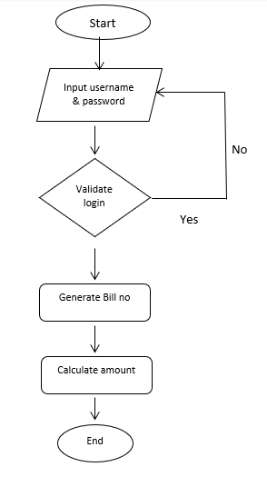

Fig 5.10 Structure Chart for Billing
File I/O: Billing, Service
Output: Billing is done.

